Enable business reporting and analytics
- Sales Summary View -> instead of direct querying data on raw table, I had created a one view and will pass tableau to as source query so, we need to just refresh on time based
CREATE OR REPLACE VIEW vw_sales_summary AS
SELECT
f.order_id,
c.customer_name,
p.product_name,
p.category,
d.full_date,
d.month_name,
r.region_name,
f.sales_amount,
f.quantity
FROM fact_sales f
JOIN dim_customer c ON f.customer_id = c.customer_id
JOIN dim_product p ON f.product_id = p.product_id
JOIN dim_date d ON f.date_id = d.date_id
JOIN dim_region r ON f.region_id = r.region_id;

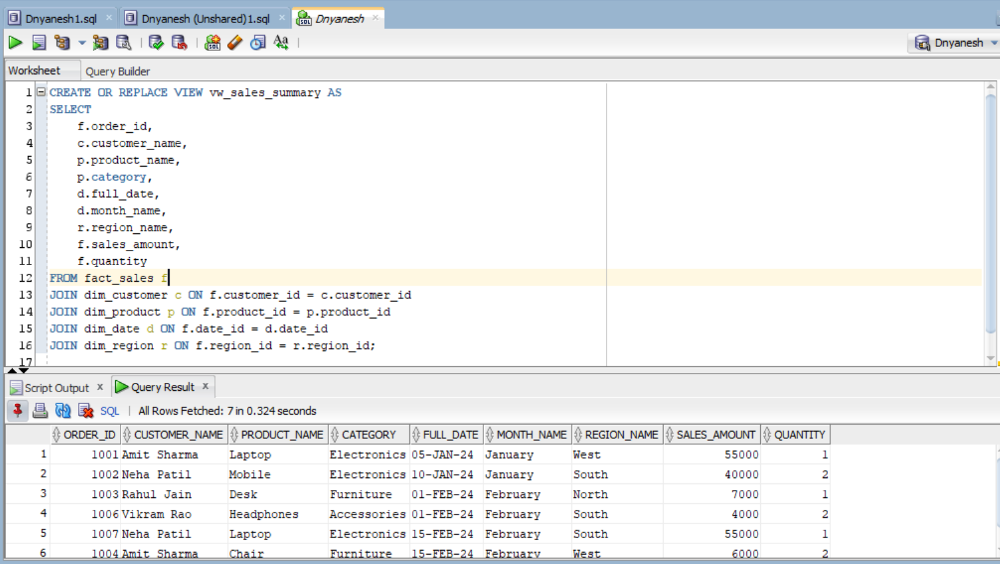

2. Business Reporting Queries
a) Total Revenue KPI
SELECT SUM(sales_amount) AS total_revenue
FROM vw_sales_summary;
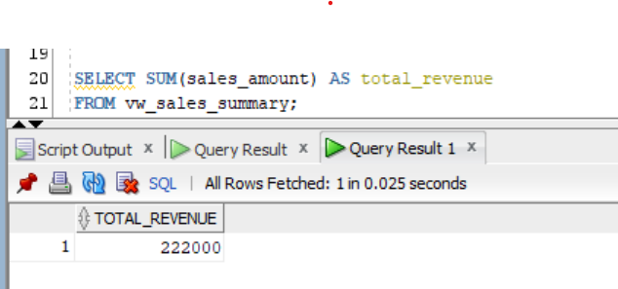

b) Monthly Sales Trend

select month_name,
sum (sales_amount) from vw_sales_summary
group by month_name
ORDER BY MIN(full_date);

January 95000
February 72000
March 55000

c)
Top Products

SELECT
product_name,
SUM(sales_amount) AS revenue
FROM vw_sales_summary
GROUP BY product_name
ORDER BY revenue DESC;
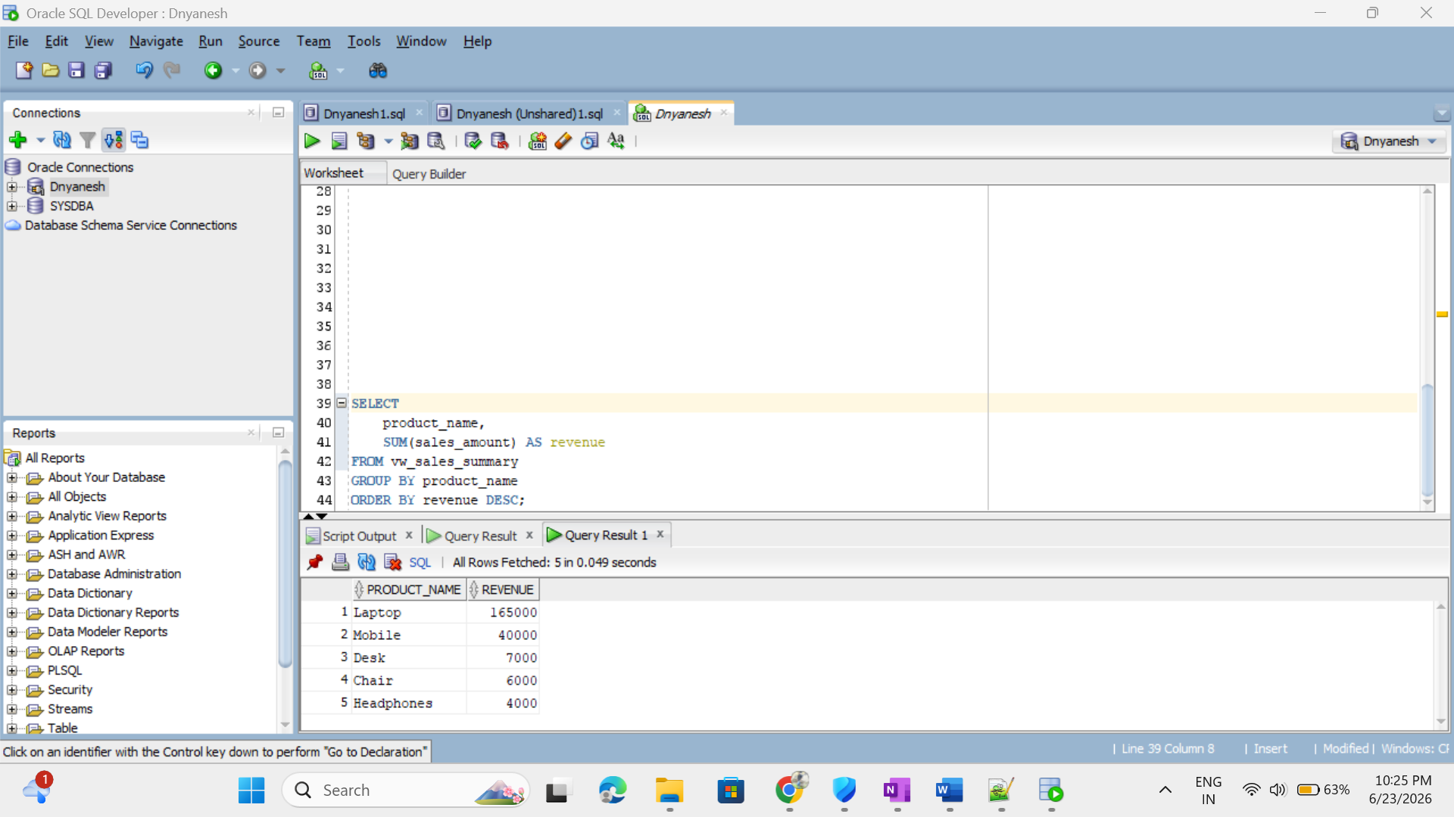

d) Region-wise Sales
SELECT
region_name,
SUM(sales_amount) AS revenue
FROM vw_sales_summary
GROUP BY region_name;
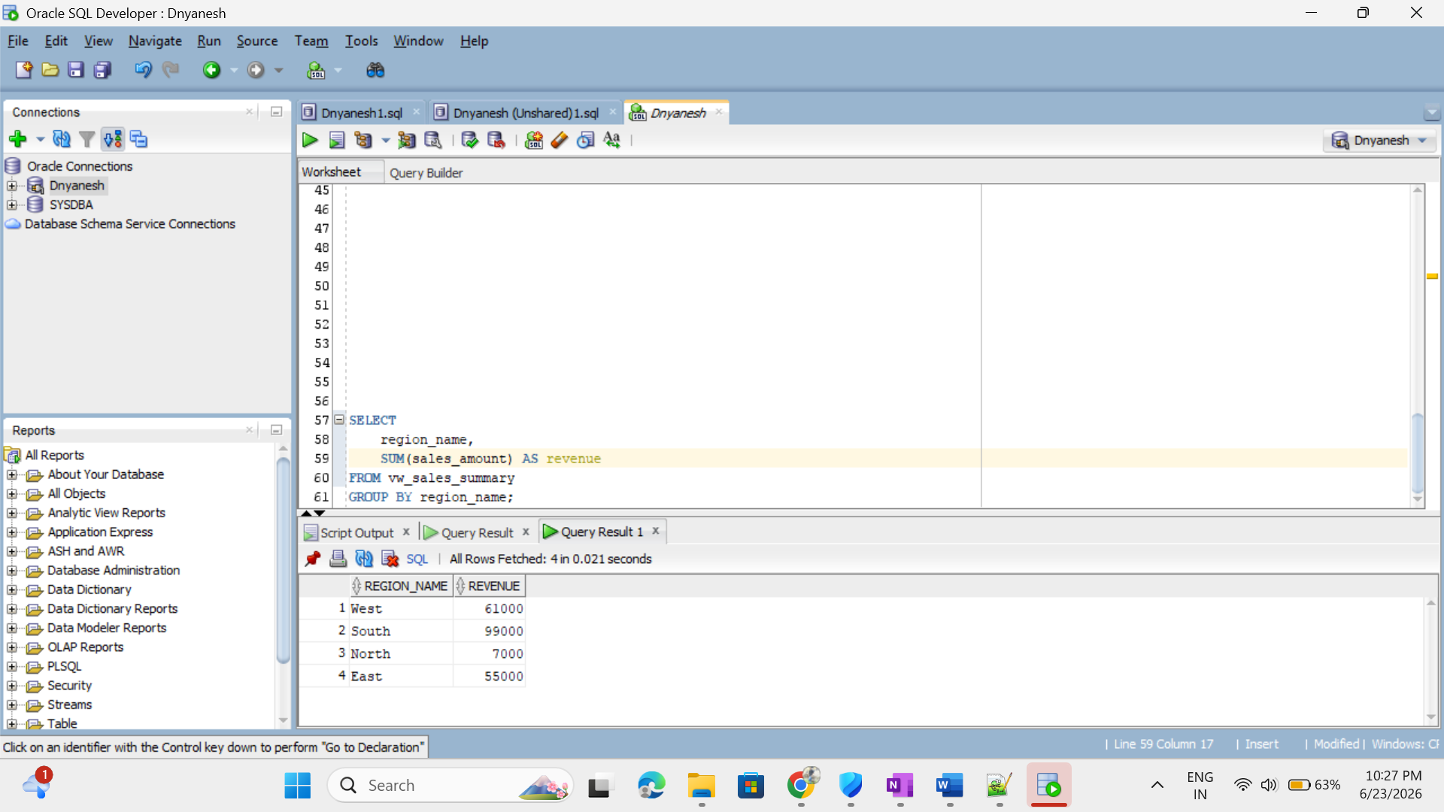

👤 Customer Segmentation
SELECT
customer_name,
SUM(sales_amount) AS total_spent,
CASE
WHEN SUM(sales_amount) > 50000 THEN 'High Value'
WHEN SUM(sales_amount) > 20000 THEN 'Medium Value'
ELSE 'Low Value'
END AS customer_segment
FROM vw_sales_summary
GROUP BY customer_name;


